Truth and False-Carbon Dioxide Mitigation Technologies
Muhammad Imran Rashid^{1,2*}
¹Department of Chemical, Polymer and Composite Materials Engineering, University of Engineering and Technology, Lahore (New Campus), 39021, Pakistan
²Discipline of Chemical Engineering, University of Newcastle, NSW 2308, Australia
*Corresponding author: muhammadimran.rashid@uon.edu.au

Abstract
Research progress is required to be enhanced for those storage technologies which store CO₂ fast and permanently. However, temporary storage technologies importance cannot be denied to immediately reduce global warming and reduce higher CO₂ concentration in the atmosphere. Continuous CO₂ storage facilities, semi-batch and batch pilot plants deemed necessary to build for future survival of the earth planet. Membranes can be used to separate CO₂ from common flue gases followed by mineral carbonation to convert CO₂ into stable carbonates. Modifications in cement industry, coal fired power plants, fertilizer industries and other chemical process industries appears essential.
Keywords: carbon dioxide storage technologies, membranes and mineral carbonation, carbon
dioxide conversion to urea, carbon dioxide conversion to chemicals and biochemicals,
mineral carbonation, Polymeric Materials

INTRODUCTION
Extreme weather patterns, recent floods especially in Europe, Antarctica glaciers melting and appearance of new lakes, extreme temperatures (54 °C, Middle East), thousands of deaths in Karachi (Pakistan) due to heat waves are as result of increased CO₂ emissions. It is reported that greenhouse gas emissions can be reduced using mineralization, geological storage, chemical production and oceanic storage and other storage technologies. It is required that all CO₂ storage technologies to be compared tentatively to sort out the best option regarding permanent storage, temporary storage and how fast or slow storage is occurring. Membranes are commonly used for different gases separation. CO2 separated from common flue gases through membranes can be easily converted in stable carbonates using mineral carbonation. Various CO₂ utilization options and there interlink with industry is discussed in this communication.
- Couple membranes and mineral carbonation
Various types for membranes can be employed for CO₂ separation from common flue gases. This separated CO₂ can be converted into stable mineral carbonates (MgCO₃, CaCO₃, FeCO₃ etc) using aqueous mineral carbonation with various rocks (dunite) and minerals (olivine, lizardite, antigorite) (Figure 1). This CO₂ separation using membranes followed by its fixation may contribute a lot in future research.

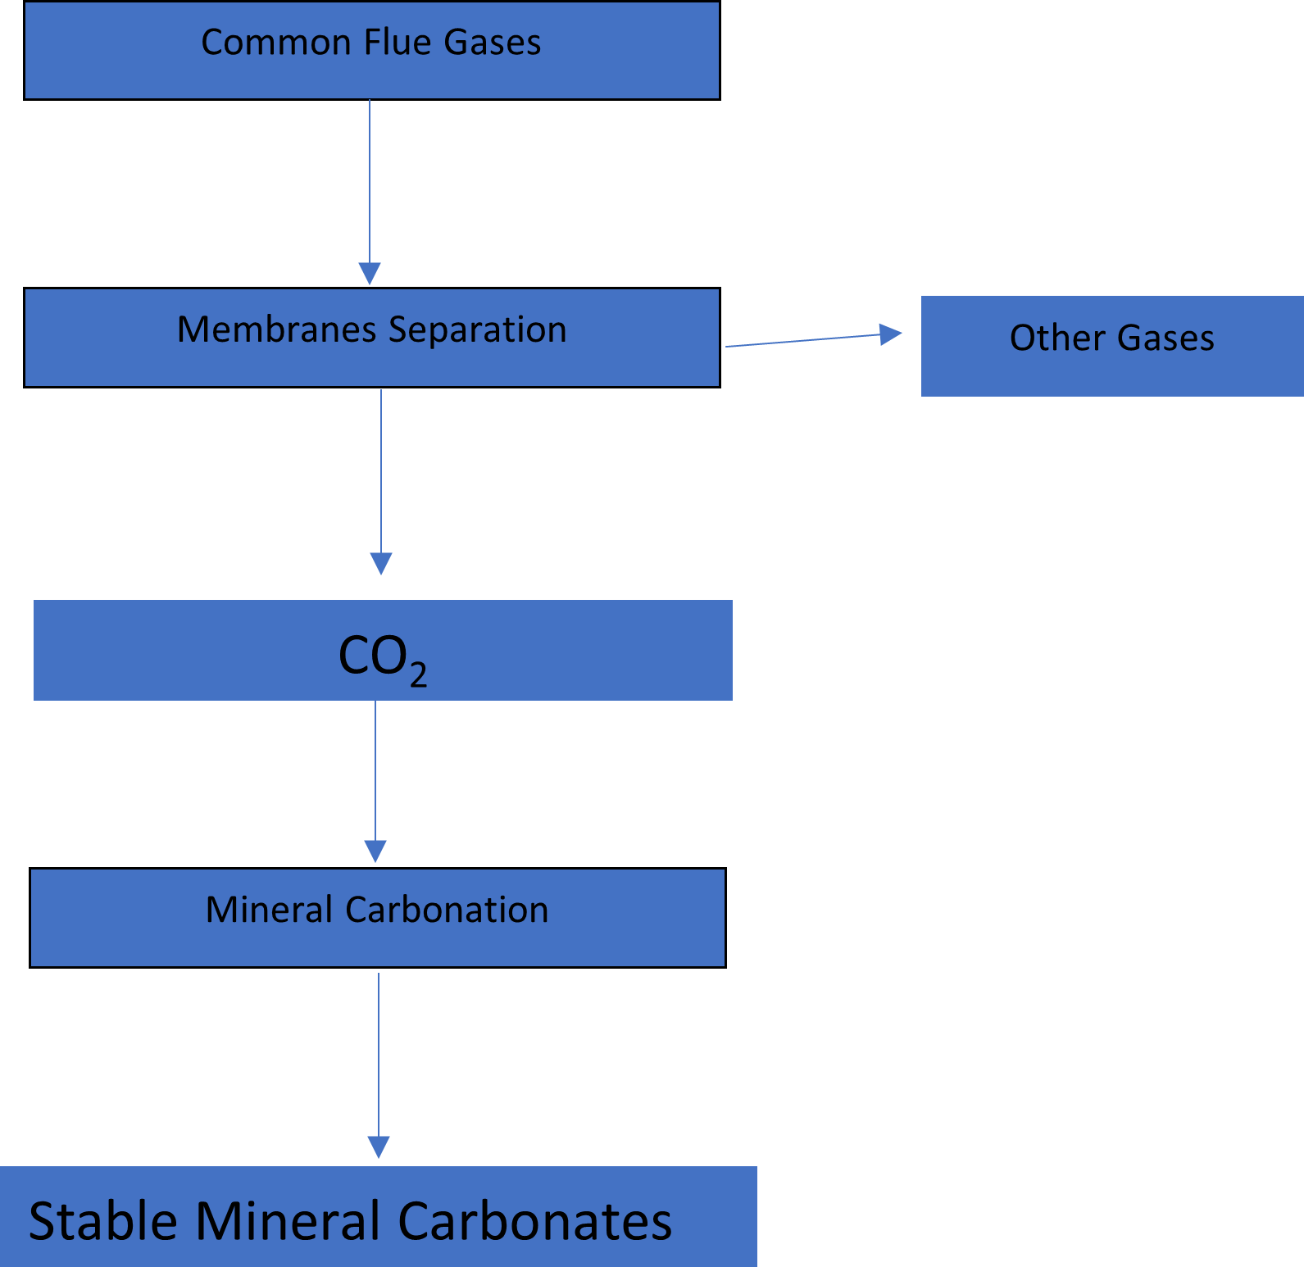
Figure 1. Use membranes for CO₂ separation from common flue gases followed by mineral carbonation to convert CO₂ into stable mineral carbonates
- CO₂ Conversion to Urea
Worldwide CO₂ is being converted into urea whose estimation is difficult, but it may be the best choice to do. Following reactions are being used to convert CO₂ into Urea in fertilizer industries [1].
CO₂+2NH₃=NH₄COOHNH₂
NH₄COOHNH₂=NH₂CONH₂+H₂O

Overall reaction
CO₂+2NH₃=NH₂CONH₂+H₂O
Urea is produced through reaction of CO₂ and ammonia which results in carbamate formation. Carbamate decompose into urea. This seems an appropriate choice as urea is being consumed by the plants. This is the best and permanent storage and at large scale.
- SOx capture at coal fired power plants
SOx emissions can be reduced through coal fired power plants which is one of the major cause of acid rain. SOx emissions are also important as CO₂ emissions. However, for energy generation, CO₂ emissions are greater as compared to CO, NOx, SO₂, particulates, formaldehyde and mercury. Natural gas is a better fuel to reduce NOx emissions as it produce 20% less NOx as compared to coal and oil.
- CO₂ conversion to carbonates
CO₂ can be converted into various (MgCO₃, CaCO₃, FeCO₃ etc) stable mineral carbonates. Peridotites and serpentinites reserves are available worldwide. Mineral carbonation is an emerging technology. Direct carbonation is better compared to indirect carbonation. Direct carbonation especially using aqueous solution is preferable. Julcour et.al performed fundamental research on concurrent grinding [2]. Concurrent grinding has shown promising results for dunite [3], heat-activated lizardite [4] and olivine. Six times higher yields were observed with dunite which is an alternative feedstock. Zirconia media is best among different medias tested so far. However, various other grinding medias are required to be tested. Heat-activated dunite, heat-activated lizardite and other rocks and minerals need to be tested using concurrent grinding. Coupling heat-activation and concurrent grinding for various peridotites and serpentinites may provide the best optimum conditions viable for sustainable development. Concurrent grinding is yet not explored during carbonation of industrial wastes (steel slags, fly ash etc). Silanol nests formation mechanism need to be explored as their formation retard higher yields. Regrinding also slightly increase yields or Mg extractions but still not comparable with concurrent grinding. Undesirable side reactions also consume amorphous materials and retard higher yields and affect process efficiency. Mineral carbonation feed and especially by-products can be used in cement manufacture. This will offset the mineral carbonation process cost and also provide a solution to waste disposal. Further research is required to explore various other mineral carbonation by-products and find why raw lizardite is not as effective as heat-activated lizardite. Acid treated silica-enriched residue has better pozzolanic activity compared to mostly used silica fume [5]. Pilot scale experiments have confirmed that yield results does not significantly differ compared to laboratory scale results proving that this mineral carbonation technology can be extended to a commercial scale continuous process industry. However, for serpentinites it has been observed that heat-activation is a necessary step as intermediate Mg-silicate phases I and II were more reactive [6].
- CO₂ utilization by microalgae
Microalgae consume CO₂. It has been reported that different types of microalgae growth parameters increased with increased percentage of CO₂ [7]. Biomass produced from microalgae can again be utilized for combustion process. Microalgae are more effective compared to terrestrial plants [8]. Plants hemicellulose can be converted into chemicals using a bioprocess. Biodiesel can be produced using ethanol through microalgae impregnating [9]. Increased temperature reduces production cost.

- Enhanced oil recovery
CO₂ is used in enhanced oil recovery but its not a permanent storage. However, its trapped temporarily but leakage chance exists. Excessive CO₂ from gas treating facilities can be supplied to fertilizer industries for urea production or for use in other industries but not related to food production.
- Geological CO₂ storage
Definitely CO₂ is stored in geological storage, but chances exist for leakage. However, its importance cannot be denied regarding immediate reduction of CO₂ emissions. Safety risk assessments and future utilization of escaped CO₂ are required to be sorted out. An erupted lake in Africa released CO₂ which killed thousands of people.
- CO₂ to chemicals
CO₂ can be converted into following chemicals (Table 1) [10]. Urea production is the highest among all chemicals. Converting CO₂ into chemicals is a permanent storage.
Table 1. List of chemicals produced by CO₂ conversion
Urea | Ethylene Carbonate | Salicylic Acid
Methanol | Di-methyl Carbonate | Cyclic Carbonates
Formaldehyde | Copolymers | Fine Chemicals
Formic Acid | Polymer Building Blocks | Other new chemicals

- CO₂ conversion to biochemicals
CO₂ can be converted into different biochemicals such as glucose, methane, methanol, oxygenates, synthetic fuels and carbon monoxide. However, this is a slow process and enzymes are required for CO₂ fixation.
- CO₂ storage in Trees/Plants
Worldwide estimation of trees and plants may not be possible, however they consume CO₂ through a photosynthesis process. This is a fast and permanent storage. Plants and trees plantation is required to be significantly increased worldwide. Plantation in deserts and bare lands requires significant attention.
- CO₂ capture through brick kilns
Brick kilns also significantly emit CO₂ and particulate matter. Scrubbers can be used to separate particulate matter while different amines can capture flue gas emissions from chimney stacks. Worldwide measures of such sort can significantly reduce greenhouse gas emissions and lead towards sustainable development. Trees and plants surrounding the brick kilns will be significantly affected from this pollution [11].
- CO₂ storage in polymers
CO₂ is also consumed during polymerization reactions. CO₂ is also consumed during plastic manufacturing. Various polymeric materials including organic polymers can store CO₂ through absorption and adsorption methods [12, 13]. This research area is required to be more progressing.

- Oceanic CO₂ storage
Oceanic storage is difficult and may pose threat to aquatic life and disturb ecological system. CO₂ escape is easy in oceanic storage but it may be considered as last option. However, vast number of oceans are available worldwide. In case of water shortage, oceanic water may be the last choice.
- CO₂ reduction via photoelectric catalysts
This research area is significantly considerable. Various catalysts and plasma technologies are being used to enhance this process [14, 15].
- CO₂ separation, reduction and reuse from cement industry
Ninety wt% CO₂ separation and reduction is possible through various proposed modifications and other released CO₂ after passing through scrubbers and more treatments can be sent to fertilizer industries where urea manufacturing is possible using this carbon dioxide. Using compressors, this CO₂ can be injected into the process lines feeding CO₂ to urea units. Either way, it’s a CO₂ reduction and fixation.
Conclusions and recommendations
Converting CO₂ into urea is the best choice. Plants consume urea and CO₂ is fixed permanently. SOx emissions can be reduced through coal fired power plants to avoid acid rain. Natural gas is preferable fuel compared to coal and oil. Mineral carbonation fix CO₂ into stable carbonates. Concurrent grinding proved good for dunite, heat-activated lizardite and olivine. Different uninvestigated grinding medias need to be explored. Industrial wastes are required to be tested using concurrent grinding. Microalgae consume CO₂ and produced biomass can be reused for combustion after drying. CO₂ used for enhanced oil recovery may not be called a permanent storage. Trapped CO₂ can be supplied to fertilizer industry after minimal treatment. CO₂ leakage chance exist in geological storage. CO₂ can be converted into various chemicals and biochemicals. Membranes can be used for CO₂ separation from common flue gases followed by mineral carbonation to convert CO₂ into stable carbonates. CO₂ storage in trees and plants is fast and permanent. Amines can be used to capture CO₂ from brick kilns. Various polymer materials also absorb and adsorb CO₂. Oceanic CO₂ storage may pose threat to aquatic life and disturb ecological system. CO₂ reduction via photoelectric catalysts is also important. CO₂ from cement industry can be used for urea production after minimal treatment.
References
[1] M.I. Rashid, N. Ramzan. Fluid Mechanics and Heat-Transfer Operations Combination Involved in Urea Unit of Fertilizer Complex, Non-Metallic Material Science 1(1) (2019) 5-10.
[2] C. Julcour, F. Bourgeois, B. Bonfils, I. Benhamed, F. Guyot, F. Bodénan, C. Petiot, É. Gaucher, Development of an attrition-leaching hybrid process for direct aqueous mineral carbonation, Chemical Engineering Journal 262 (2015) 716-726.
[3] M.I. Rashid, E. Benhelal, F. Farhang, T.K. Oliver, M.S. Rayson, G.F. Brent, M. Stockenhuber, E.M. Kennedy, Development of Concurrent grinding for application in aqueous mineral carbonation, Journal of Cleaner Production 212 (2019) 151-161.
[4] M.I. Rashid, E. Benhelal, F. Farhang, T.K. Oliver, M. Stockenhuber, E.M. Kennedy, Application of a concurrent grinding technique for two-stage aqueous mineral carbonation, Journal of CO₂ Utilization 42 (2020) 101347.
[5] E. Benhelal, M.I. Rashid, M.S. Rayson, T.K. Oliver, G. Brent, M. Stockenhuber, E.M. Kennedy, “ACEME”: Synthesis and characterization of reactive silica residues from two stage mineral carbonation Process, Environmental Progress & Sustainable Energy 38(3) (2019) e13066.
[6] Emad Benhelal, J. Hook, Guangyu Zhao, Muhammad Imran Rashid, Tim Oliver, Mark Rayson, Geoff Brent, Michael Stockenhuber, Eric Kennedy, Insights into chemical stability of Mg-silicates and silica in aqueous systems using 25Mg and 29Si solid-state MAS NMR spectroscopy: Applications for CO₂ capture and utilisation, Chemical Engineering Journal (2020).
[7] E. Aghaalipour, A. Akbulut, G. Güllü, Carbon dioxide capture with microalgae species in continuous gas-supplied closed cultivation systems, Biochemical Engineering Journal 163 (2020) 107741.
[8] D. Tang, W. Han, P. Li, X. Miao, J. Zhong, CO₂ biofixation and fatty acid composition of Scenedesmus obliquus and Chlorella pyrenoidosa in response to different CO₂ levels, Bioresource Technology 102(3) (2011) 3071-3076.
[9] A. Jafari, F. Esmaeilzadeh, D. Mowla, E. Sadatshojaei, S. Heidari, D.A. Wood, New insights to direct conversion of wet microalgae impregnated with ethanol to biodiesel exploiting extraction with supercritical carbon dioxide, Fuel 285 (2021) 119199.
[10] E. Alper, O. Yuksel Orhan, CO₂ utilization: Developments in conversion processes, Petroleum 3(1) (2017) 109-126.
[11] K. Achakzai, S. Khalid, M. Adrees, A. Bibi, S. Ali, R. Nawaz, M. Rizwan, Air pollution tolerance index of plants around brick kilns in Rawalpindi, Pakistan, Journal of Environmental Management 190 (2017) 252-258.
[12] A. Sattari, A. Ramazani, H. Aghahosseini, M.K. Aroua, The application of polymer containing materials in CO₂ capturing via absorption and adsorption methods, Journal of CO₂ Utilization 48 (2021) 101526.
[13] H. M. Safaa, A.S. Hameed, E. Yousif, M. H. Alotaibi,, M.H. Alotaibi, D.S. Ahmed, G.A. El-Hiti, New Porous Silicon-Containing Organic Polymers: Synthesis and Carbon Dioxide Uptake, Processes 8 (2020).
[14] Ni, Z. L. Liang, Yi, Z., R. Guo, C. Liu, Y. Liu, H. Sun, X. Liu, Research progress of electrochemical CO2 reduction for copper-based catalysts to multicarbon products, Coordination Chemistry Reviews 441 (2021) 213983.
[15] C. Xu, X. Zhang, M.-N. Zhu, L. Zhang, P.-F. Sui, R. Feng, Y. Zhang, J.-L. Luo, Accelerating photoelectric CO₂ conversion with a photothermal wavelength-dependent plasmonic local field, Applied Catalysis B: Environmental 298 (2021) 120533.

