julho 31, 2026

Principal Editors: Non-Metallic Material Science

Dear sirs,

Accompanying this letter is a manuscript entitled “INCORPORATION OF SUGARCANE BAGASSE ASH IN RED CERAMICS SINTERED IN MICROWAVE OVEN” authored by Gabriela Pitolli Lyraª*, Valdemir Santosª, Eliria Maria de Jesus Agnolon Palloneª, Ruth Herta Goldschmidt Aliaga Kiminami^{b}, Bruno Carlos De Santis^{b}, João Adriano Rossignoloª.

ªPostgraduate Programme in Materials Science and Engineering, University of São Paulo, USP/FZEA, Av. Duque de Caxias Norte, 225, 13.635-900 - Pirassununga, Brazil.
bDepartment of Materials Engineering, Federal University of São Carlos – UFSCAR, Rod. Washington Luiz, km 235, 13.565-905 - São Carlos, Brazil.

* Corresponding author at the Department of Biosystems Engineering, São Paulo University, USP, Av. Duque de Caxias Norte, 225, 13635-900 Pirassununga, SP, Brazil
Phone: + 55 1935656816, fax: + 55 19996310347.

This work evaluated the influence of the addition of sugar cane bagasse ash in red ceramics used in many application. Different sintering methods, conventional sintering and microwave sintering were evaluated. The addition of organic materials in the red ceramic provided a decrease in the specific gravity of the material. The decrease in the compressive strength values and the increase in water absorption caused by the appearance of pores was partially offset by sintering in a microwave oven.

We have specifically selected NON-METALLIC MATERIAL SCIENCE journal as the ideal forum in which to publish this manuscript, as we feel that its broad-based audience will obtain significant value from the data presented.

No part of this manuscript has been published or is under review elsewhere. This manuscript (except affiliations, acknowledgments and references) has been analysed for plagiarism (Turnitin software). We look forward to your response.

This section confirms that written consent was obtained from all participants prior to the study. The authors declare that they have no known competing financial interests or personal relationships that could have appeared to influence the work reported in this paper.

Yours sincerely,

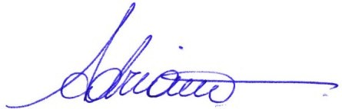
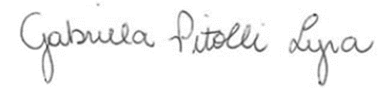

Signed: Gabriela Pitolli Lyra

