Synthesis and Characterization of 4,4′-Dibromoazobenzene

Ranran Zhen¹, Wei Lu^{1*}, Yun Zhou¹, Minzhen Feng¹,Ya Wang¹
¹College of Chemistry, Chongqing Normal University, Chongqing, People’s Republic of China

Abstract: Azobenzene molecules show excellent application potential in many fields due to their photoisomerization properties. Azobenzene molecules will gradually change from trans-structure to cis-structure under the irradiation of UV. In this paper, we have synthesized 4,4'-dibromoazobenzene molecules and characterized their photoisomerization properties. We found that with the extension of UV time, the trans absorption peak at 343 nm decreased significantly, while the cis absorption peak at 435 nm showed an upward trend. Furthermore, photoisomerization of azobenzene is not a first-order reaction.
Keywords: Azobenzene; Photoisomerism

Introduction
Azobenzene molecules and their derivatives refer to aromatic compounds containing a functional structure of -N=N- in the molecule. In 1858, Johann ^{[1]} discovered a diazotization reaction that could be used to synthesize azobenzene compounds. Under the specific wavelength of light radiation, azobenzene molecules will have obvious photochromism. This phenomenon is because azobenzene molecules have two geometric isomers. They can be converted to each other under the stimulation of a specific wavelength of light. This phenomenon is called photoisomerism. Azobenzene molecules can undergo trans to cis conversion under the irradiation of ultraviolet light, and cis to trans conversion can be achieved under the irradiation or heating of visible light (Figure 1).
Figure 1 Photoisomerization of azobenzene
The classic methods for preparing azobenzene are azo coupling reaction, Mills reaction, and Wallach reaction. The azo coupling reaction is a nucleophilic reaction with short reaction time and high yield ^{[2]}. Primary aromatic amines initially diazotized at low temperatures before reacting with electron-rich phenol. Diazonium salts are weak electron systems and are prone to reactions in electron-rich systems ^{[3]}. This reaction needs to be performed in an acidic environment ^{[4]}. The reaction of aromatic nitroso derivatives and aniline in glacial acetic acid is the Mills reaction ^{[5]}. Aromatic nitroso derivatives can be prepared from aromatic methyl hydroxylamine by t-butyl hypochlorite oxidation. This oxidation reaction needs to be carried out in a dilute solution at -78℃to prevent excessive oxidation. For the Wallach reaction, there is an explanation of the reaction mechanism. Azobenzene oxide is first protonated, dehydrated, and isomerized, and then attacked by nucleophiles. After rearrangement, azobenzene products are obtained^{[6]}. In this paper, 4,4'-dibromoazobenzene is prepared from 4-bromoaniline by the method of primary oxidizing amines to azo by KMnO₄ supported on Fe(Ⅱ)SO₄ (Figure 2) benzene. The trans to cis conversion was achieved under UV light at 365 nm.
Figure 2 Synthesis of 4,4’-dibromoazobenzene

Experiment

Synthesis of 4,4’-dibromoazobenzene
Pour equal amounts of KMnO₄ (5 g) and FeSO₄ • 7H₂O (5 g) in a mortar and lightly grind (to prevent oxidation of ferrous ions) to obtain the oxidant. 4-Bromoaniline (1.75 g, 1 mmol) was placed in a 250 mL round bottom flask, dissolved in dichloromethane, and a homogeneous mixture of oxidant (10.0 g) was added thereto. The mixture was refluxed for 6 h. The reaction mixture was cooled to room temperature and filtered through celite. The residue was washed with CH₂Cl₂ (3 x 15 ml) and ether (3 x 15 ml). The resulting solution was dried over anhydrous sodium sulfate. The solvent was removed and purified by column chromatography (basic alumina, 200-300 mesh, n-hexane: ethyl acetate = 4: 1). Vacuum drying box at 60℃ for 6h. An orange-red solid was obtained (87% yield). ¹ H NMR (300 MHz, CDCl₃ ) δ 7.80 (d, J = 8.68 Hz, 4H，H²), 7.66 (d, J = 8.68 Hz, 4H, H¹).
UV irradiation experiment
Use a volumetric flask to accurately configure 4, 4'-dibromoazobenzene with a concentration of 3 × 10⁻⁵ mol / L ethyl acetate solution. Add 1 ml of the ethyl acetate solution in 1.5 ml centrifuge tubes. The tubes were irradiated with 450 nm LED blue light for 30 min in order to convert all cis-azobenzene molecules into trans. The tubes were irradiated with a 365 nm UV lamp in a dark box, and a solution was taken every 1 minute for UV-vis spectrophotometry.

Results and discussion

The ¹H NMR (Figure 3) of the product showed that the ratio of the integrated values of 1 and 2 was 0.99: 1. This result is consistent with the theoretical value. Therefore, 4, 4'-dibromoazobenzene can be prepared by the method of oxidizing primary amine to azo by KMnO₄ supported on Fe (II) SO₄.
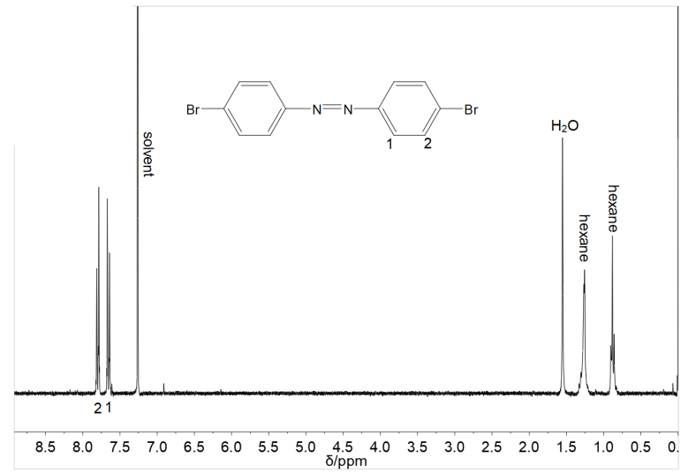
Figure 3 ¹H NMR spectrum of 4, 4’-dibromoazobenzene（CDCl3，300 MHz，298 K）
Figure 4 shows the UV-vis absorption spectrum of 4,4'-dibromoazobenzene. From the image, we found that with the increase of the 365 nm UV lamp irradiation time, the absorption peak at 343 nm gradually decreased, while the absorption peak at 435 nm showed an upward trend.
Figure 4 UV-vis absorption spectrum of 4,4'-dibromoazobenzene.
Under UV radiation at 365 nm, 4,4'-dibromoazobenzene will undergo a π-π * transition, and its structure will change from trans to cis. The absorption at the wavelength of 343 nm corresponds to the trans structure, and the absorption at the wavelength of 435 nm corresponds to the cis structure. The formula for the first-order reaction is as follows:
(1)
Then through Lambert-Beer law (2).
Where c is the solution concentration, K is the reaction rate constant, is the molar absorbance, and b is the cuvette thickness ^{[7]}. Wherein the molar absorbance, cuvette thickness, and reaction rate constant are all quantitative, and we can derive that:
(3)
Substitute Figure 4 data into the formula and find that the value of K is variable. This result indicates that the reaction is not a first-order reaction.

Conclusion

In this paper, we successfully synthesized 4,4'-dibromoazobenzene molecules via KMnO₄ and Fe (Ⅱ) SO₄·7H₂O and characterized their photoisomerization properties. We found that with the extension of UV light irradiation time, the trans absorption peak at 343 nm decreased significantly, while the cis absorption peak at 435 nm showed an upward trend. The photoisomerization of azobenzene is not a first-order reaction.

Acknowledgements：This work was supported by The National Natural Science Foundation of China (21504010); Open Project of Engineering Research Center of Active Material Biotechnology, Ministry of Education, Chongqing Normal University (AS201609); Chongqing Key Laboratory of inorganic Function Materials, College of Chemistry, Chongqing Normal University, Chongqing 401331, P.R. China.

References

[1] Mayo D W, Pike R M, Trumper P K. Microscale Organic Chemistry[J]. 1994.
[2] Haghbeen K, Tan E W. Facile synthesis of catechol azo dyes[J]. The Journal of Organic Chemistry, 1998, 63(13): 4503-4505.
[3] Merrington J, James M, Bradley M. Supported diazonium salts—convenient reagents for the combinatorial synthesis of azo dye[J]. Chemical communications, 2002 (2): 140-141.
[4] Breslow R, Schmuck C. The mechanism of thiazolium catalysis[J]. Tetrahedron letters, 1996, 37(45): 8241-8242.
[5] Davey M H, Lee V Y, Miller R D, et al. Synthesis of aryl nitroso derivatives by tert-butyl hypochlorite oxidation in homogeneous media. Intermediates for the preparation of high-hyperpolarizability chromophore skeletons[J]. The Journal of organic chemistry, 1999, 64(13): 4976-4979.
[6] Nanjundaswamy H M, Pasha M A. Facile, Product‐Selective Reduction of Azoxyarenes into Azoarenes or Hydrazoarenes by Aluminium/Hydrazine Hydrate[J]. Synthetic communications, 2005, 35(16): 2163-2168.
[7] Xue Xiao Qiang ,Synthesis and optical properties of novel azobenzene functional polymer [D].Soochow University .2010

