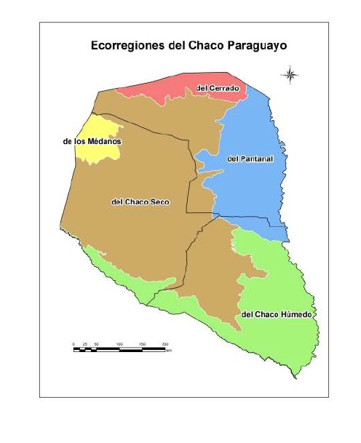
Figure 1. Ecorregions of the Paraguayan Chaco.

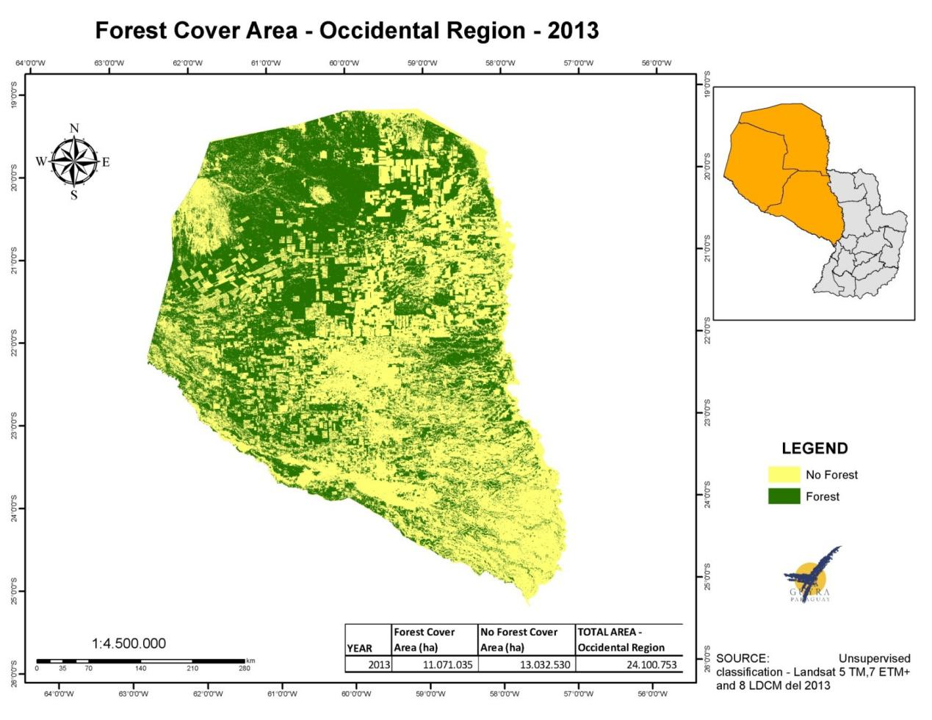
Figure 2. Changes in land use.

Figure 3. Wild protected areas in the Paraguayan Chaco.
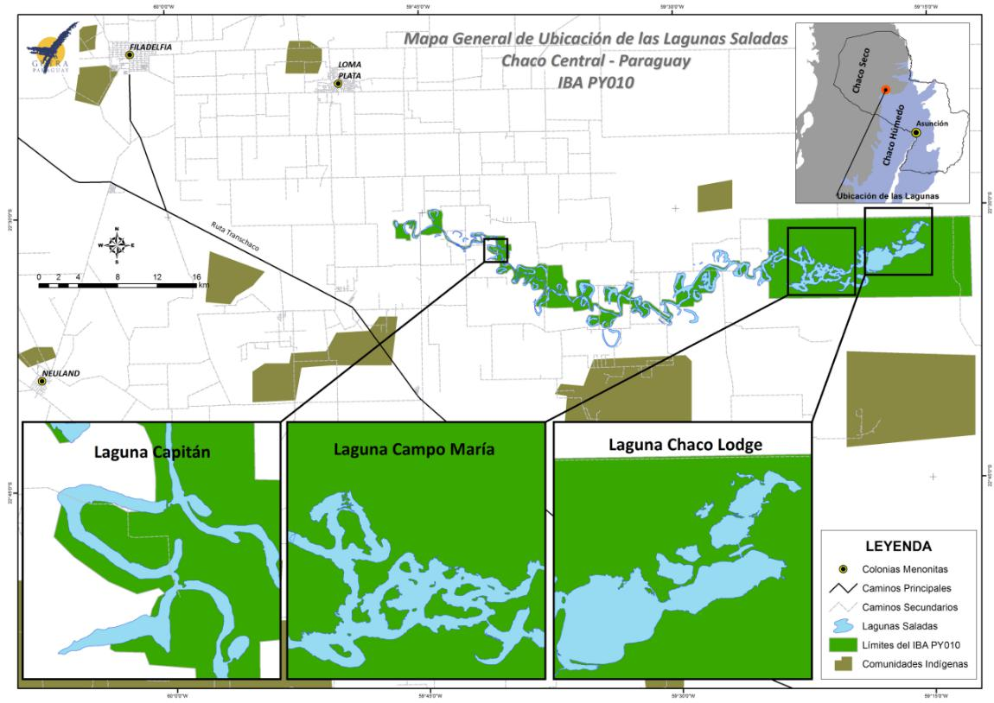
Figure 4. Locations of the peri-urbans corridors around Filadelfia, Mariscal Estigarribia and Loma Plata, Central Chaco.

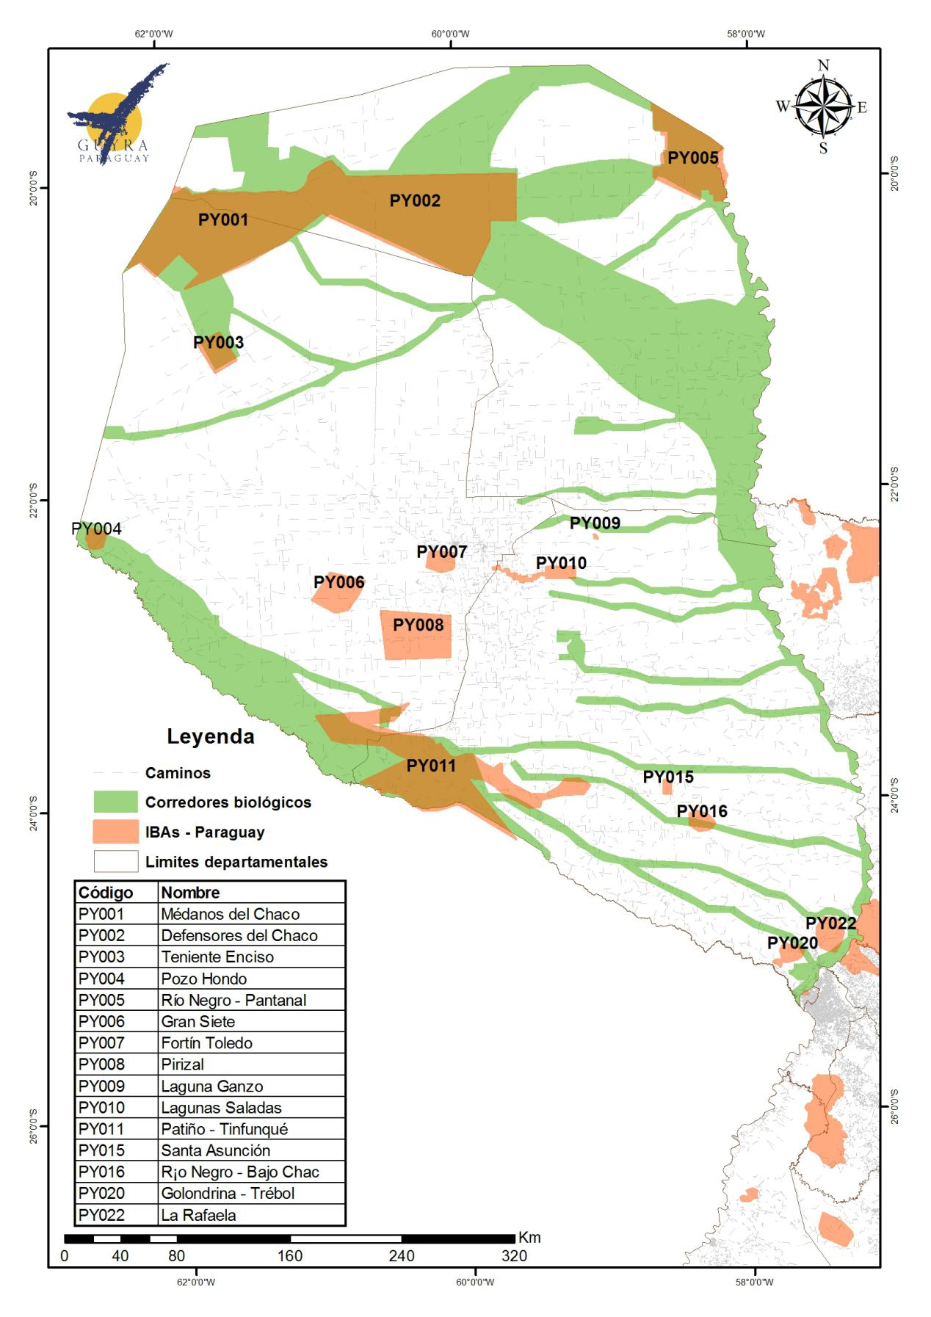
Figure 5. Map with the aproximate location of the proposed Biological Corridors.

