Supplementary tables and figures
Table 1: Description summary of studied area
Table 2: Major various species observed in the study area
Figure 1: Location map of the studied cities

Table 1: Description summary of studied area
Cities | Altitude (m) | Latitude | Longitude | Temperature (°C) | Rainfall (mm) | Population
Adama | 1620 | 8°32′24″ N | 39°16′12″ E | 21 | 838 | 150,228
Bishoftu | 2135 | 8°43′26″ N | 38°56′24″ E | 20 | 1076 | 85265
Burayu | 2600 | 9°02′30″ N | 38°03′30″ E | 14-22 | 1188 | 76,681
Sabata | 2065 | 8°53′38″ N | 38°35′11″ E | 13-25 | 1605 | 97,554

Table 2: Major various species observed in the study area
No. | Trees | Shrubs | Grass
1 | Acacia saligna | Carissa edulis | Cymbopogon martini
2 | Acacia tortolis | Dovyalis abyssinica | Dahilia sp.
3 | Azadrachta indica | Phoenix reclinata | Pennisetum clandestinum
4 | Cordia africana | Dovyalis abyssinica | Arundo donax
5 | Croton macrostachyus | Psidium guajava | Gazania thermalis
6 | Cupressus pyramidalis | Punica granatum | Aloe vera
7 | Spathodea niloitica | Rosa abyssinica | Mussa enseta
8 | Delonix regia | Hibiscus rosasinesis | Gazania thermalis
9 | Ficus vasta | Lantana montevidensis
10 | Mangifera indica | Coffee Arabica
11 | Persea americana

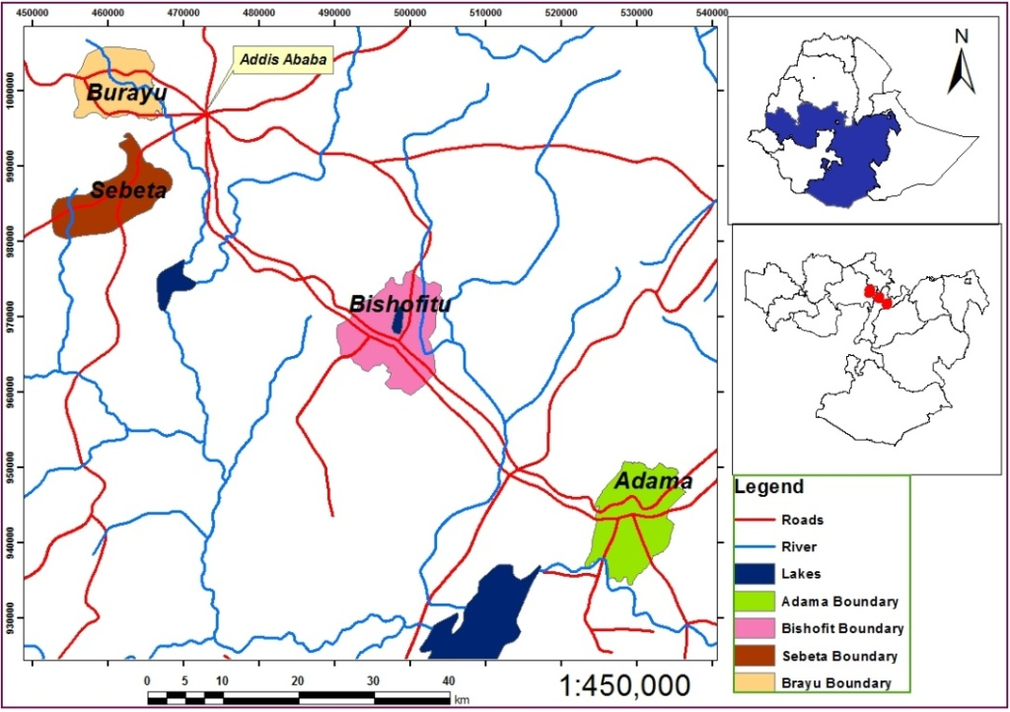
Figure 1: Location map of the studied cities

