Supplementary information
Figures

Figure 1: Map of the study site
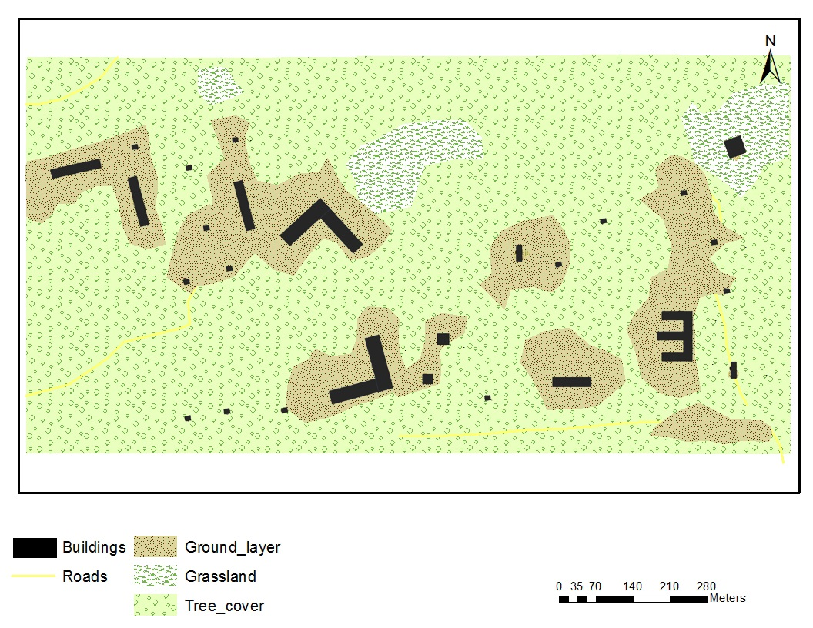
Figure 2: Nests of Black Robin in different places (A) post boxes, (B, C) joists of buildings
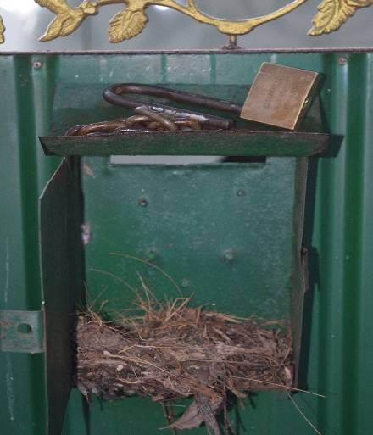
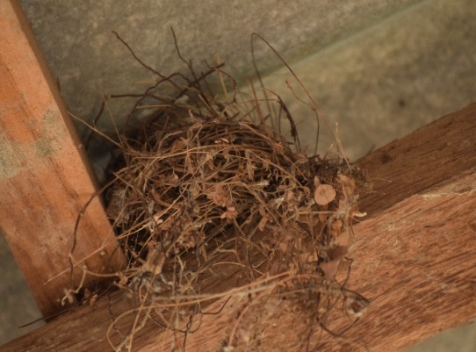

C
A
B

Figure 3: Eggs of Indian Black Robin
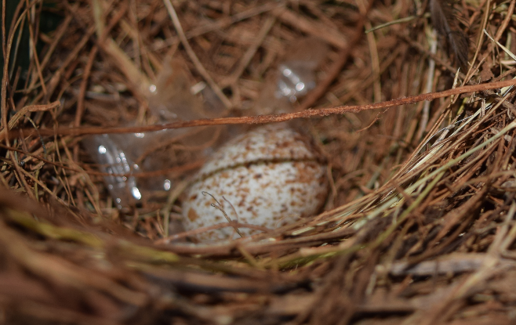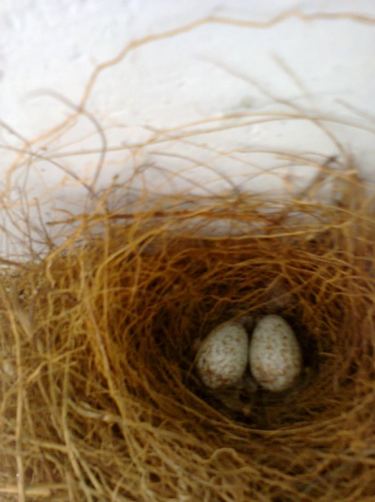

Figure 4: Incubation behaviour of female Indian Black Robin
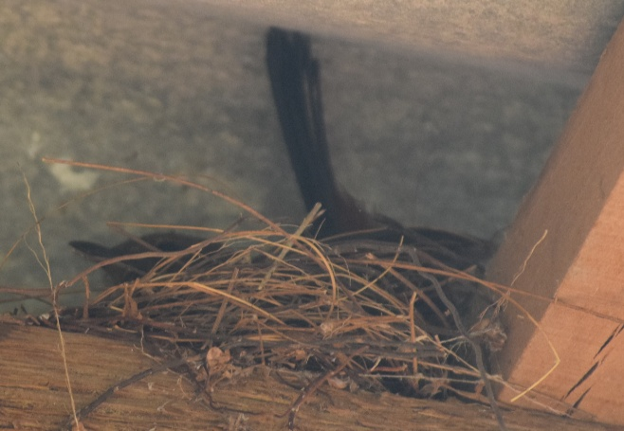

Figure 5: Fledglings fed by male black robin
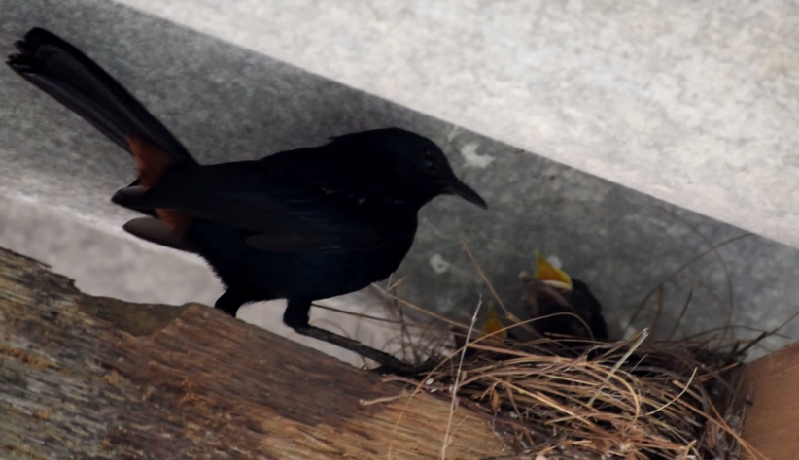

Figure 6: Behavioral patterns of male and female during the breeding period
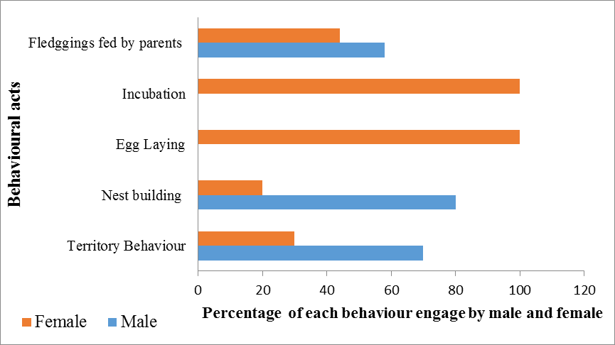

Figure 7: Non-breeding and breeding territories of Indian Black Robin
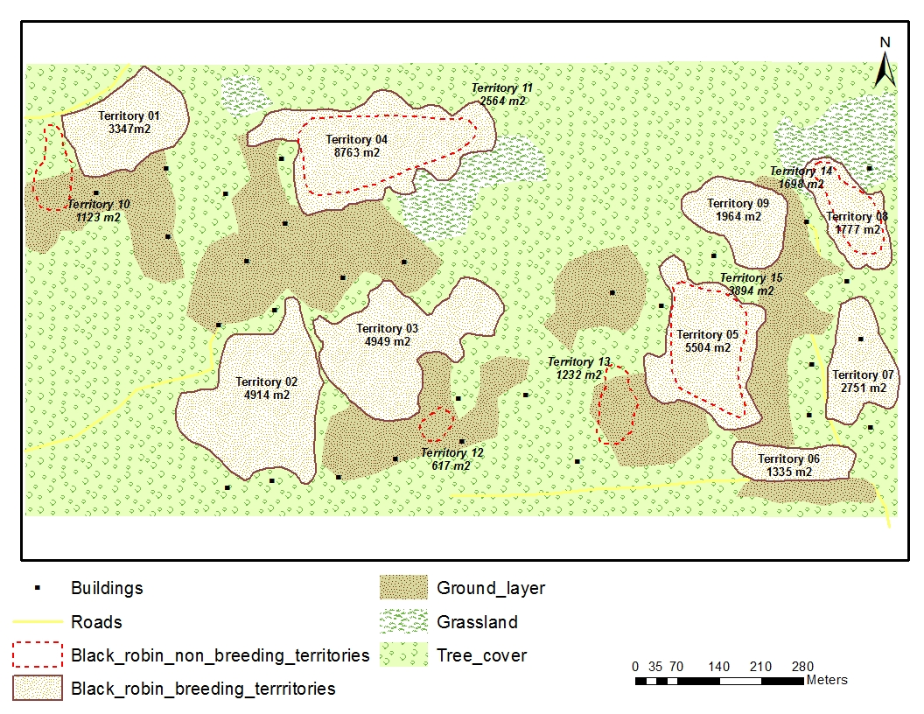

Figure 8: Percentage time expenditure for different behaviour of Black Robin during the study period
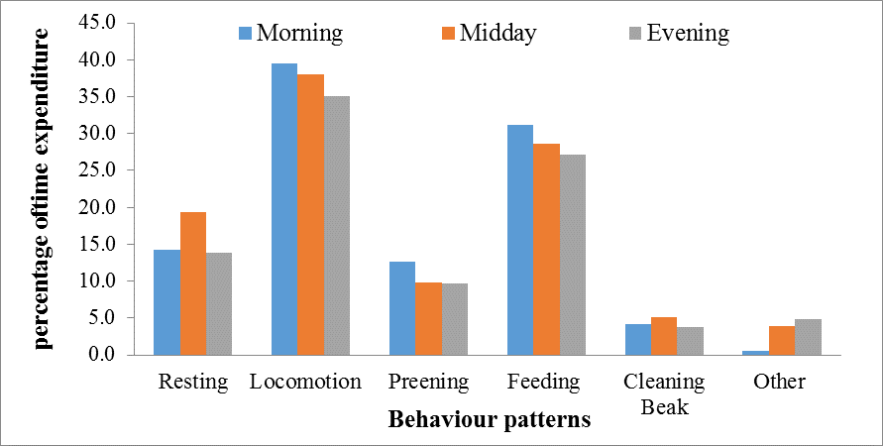

Tables

Table 01: Number of nests and territory sizes in each period during breeding season
Territory No | Total number  of  nests observed | Number of Successful nests | Number of abandoned  nests | Number  of observed eggs | Number  of chicks hatched | Size of the territory in breeding season (m²)
2014
01.Feb - April | 1  1  1 | - | 1 | - | - | 3347
02 March - April | 1  1  1 | 1 | - | 4 | 2 | 4914
03. April – May | 1  1  1 | 1 | - | 4 | - | 4949
2015
04. Feb - April | 1  1  1 | - | 1 | - | - | 8763
05. Feb - April | 1  1  1 | 1 | - | 4 | 2 | 3246
06. August - Sept | 1  1  1 | 1 | - | 2 | - | 1758
2016
07. August-Sept | 2 | 1 | 1 | 1 | - | 2751
2017
08 March - April | 1  1 | 1 | - | 2 | 2 | 1335
09. August - Sept | 1  1 | 1 | - | 4 | - | 1964

