Supplementary Materials for
“ Intrinsic Photoconductivity of few-layered ZrS₂ Phototransistors via Multiterminal Measurements”

Figure S1: AFM image and height trace of one of the exfoliated flakes of ZrS₂ on to Si/SiO₂ substrate.
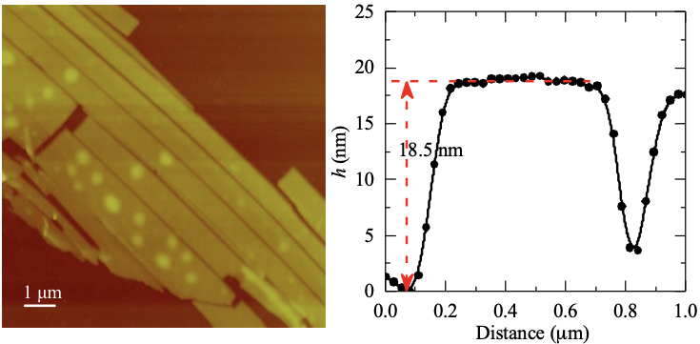

AFM height measurements were performed on several exfoliated crystals of ZrS₂ on Si/SiO₂ substrate using Veeco Dimension 3100 AFM setup. The flakes used for optical measurements are from 8 nm to 15 nm thick.

Figure S2. Photocurrent vs incident optical power
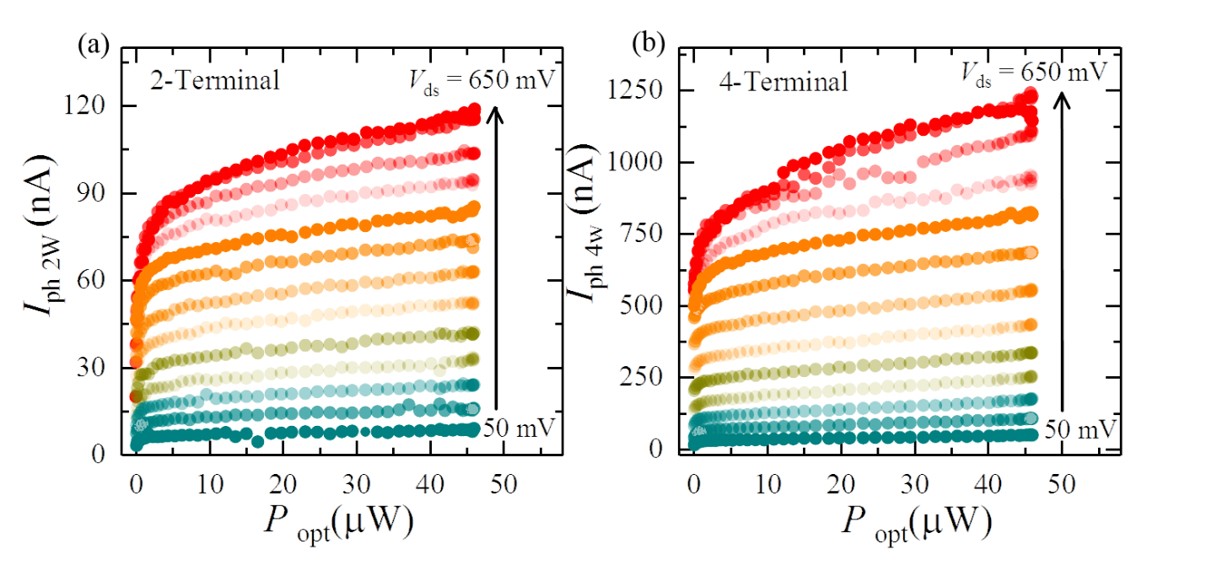 The photocurrent as a function of incident optical power under several bias voltages for (a) two-terminal configuration (b) four-terminal configuration (I_{ph2W} and I_{ph4W} denote the photocurrent with two and four-terminal configurations, respectively). The four-terminal photocurrent is significantly larger (>1000 %) than the two-terminal current. Under both configurations, the photocurrent increases with the bias voltage.

